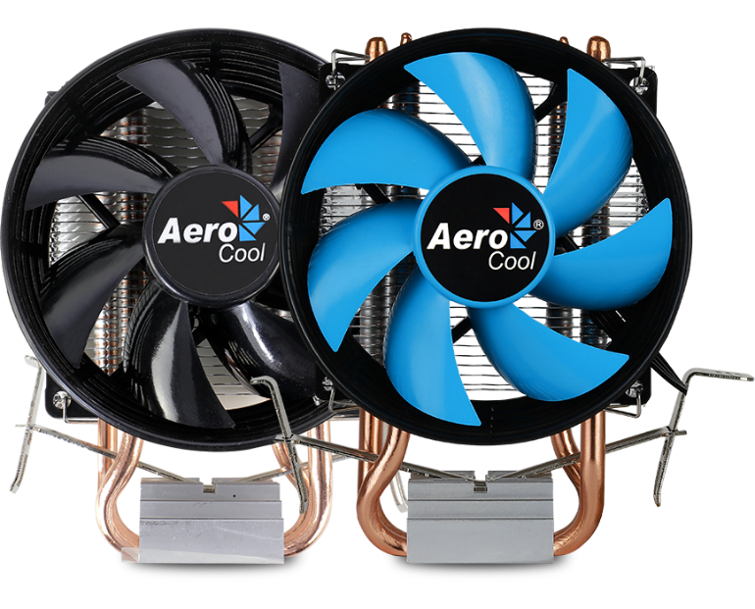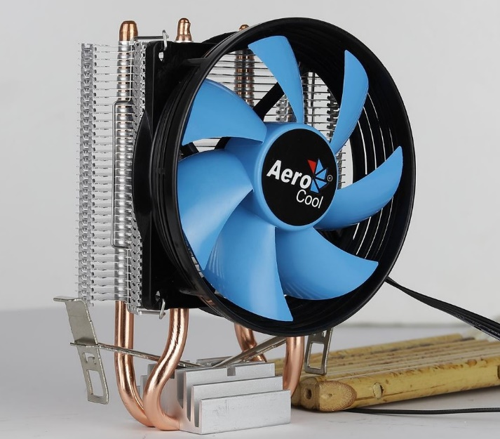
*Color option of the fan blade may vary. Contact point of purchase or reseller for more information.

Product Overview:
Comes with 2 ultra-efficient thermal heat pipes. Capable of mounting single 90mm fan configurations. PWM air cooling solution powered by Heat Core Touch Technology (HCTT) and equipped with high efficiency fins. Compatible with most current motherboard designs.
Specifications

 | Model |  |  | Verkho 2
 | Base Material |  |  | Aluminum block with HCTT Heat Core Touch Technology
 | Fin Material |  |  | Aluminum
 | Heat Pipes |  |  | Dia. 6mm x 2
 | Dimensions |  |  | 92 x 62 x 142mm
 | TDP (Thermal Design Power) |  |  | 110
 | Fan | Dimensions |  | 90 x 90 x 25mm
 |  | Speed |  | 800-2000 rpm
 |  | Connector |  | PWM 4-Pin
 |  | Bearing System |  | Hydraulic
 |  | Rated Voltage |  | 12V
 |  | Starting Voltage |  | 5V
 |  | Rated Current |  | 0.15A
 |  | Power Consumption |  | 1.8W
 |  | Speed |  | 800-2000 RPM
 |  | Max Air Flow (CFM) |  | 18.5-23.6 CFM
 |  | Noise (dBA) |  | 15-25 dBA
 |  | MTBF |  | 60,000 hours
Socket |  |  | LGA 1156/1155/1151/1150/775 AM4/AM3+/AM3/AM2+/AM2/FM2/FM1

Warranty
1 year

Features

- TDP (Thermal Design Power) up to 110W.
- Compact side flow air cooler for maximum compatibility.
- Heat Core Touch Technology (HCTT) with 2 ultra-efficient thermal heat pipes.
- Upgraded high efficiency fins for optimal thermal performance.
- Ultra-slim profile capable of mounting single 90mm fan configurations; works with most current motherboard designs.

Packaging Information

Product Name | Product Number | EAN CODE | UPC CODE
Verkho 2 | ACTC-NA20210.01 | 4710700955888 | 192275000288
Carton Size (L x W x H) | 48.5 x 46.5 x 31.5CM | Carton Weight | 13.76KG
Retail Box Size (L x W x H) | 12 x 9.2 x 14CM | Retail Box Weight | 0.31KG
Carton Qty | 40 | Pallet Qty | 1600 pcs

